A:

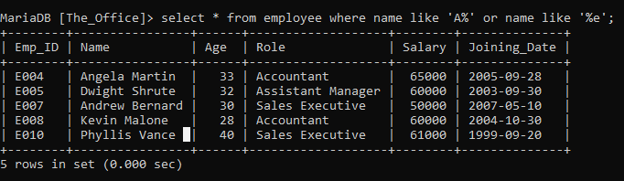

B:

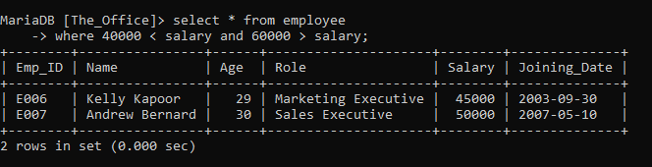

C:

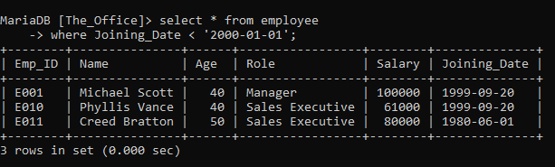

D:

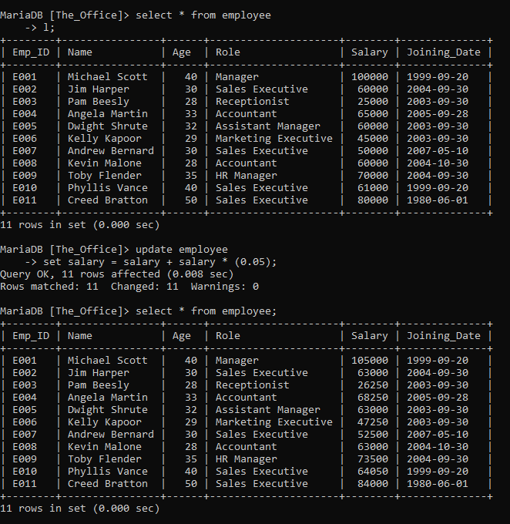

E:

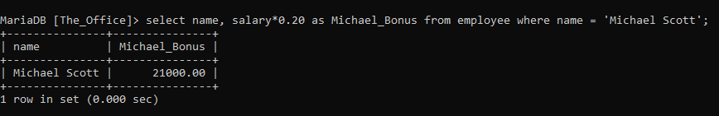

F:

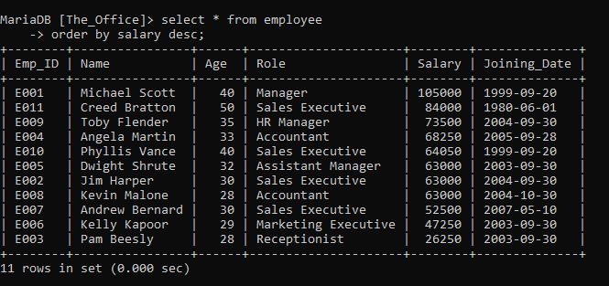

G:

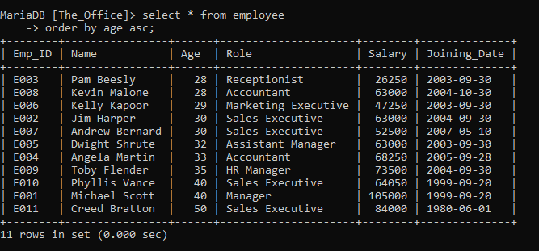

H:

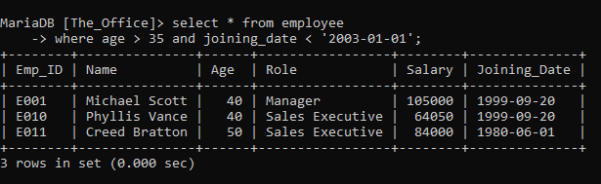

I:

delete from employee

-> where name = 'Creed Bratton';

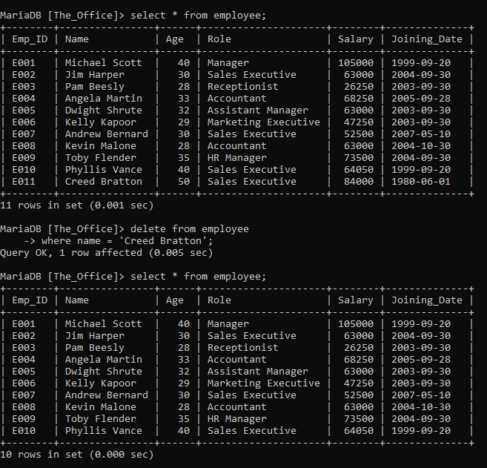

J:

select * from employee

-> where role like '%executive%';

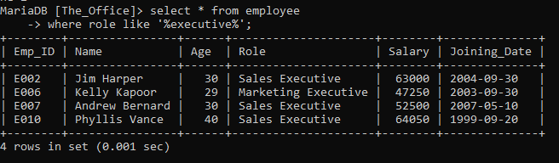

K:

alter table employee

-> change Name Employee_Name varchar(100);

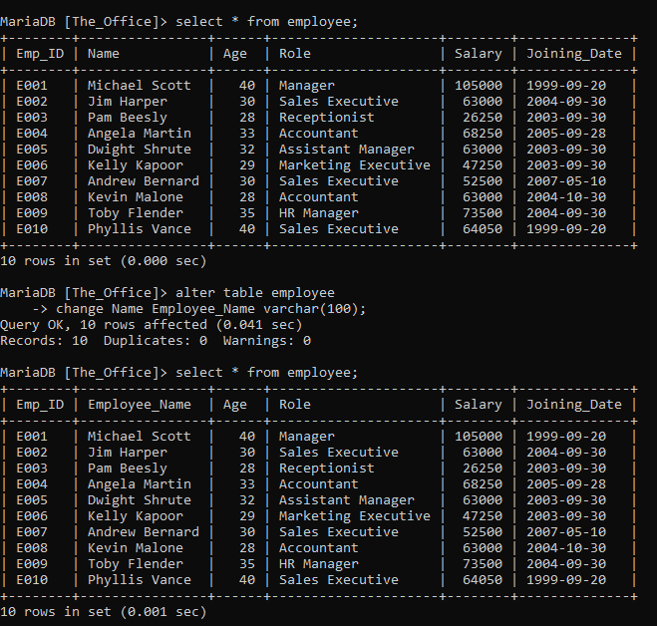

L:

alter table employee

-> add Bonus int;

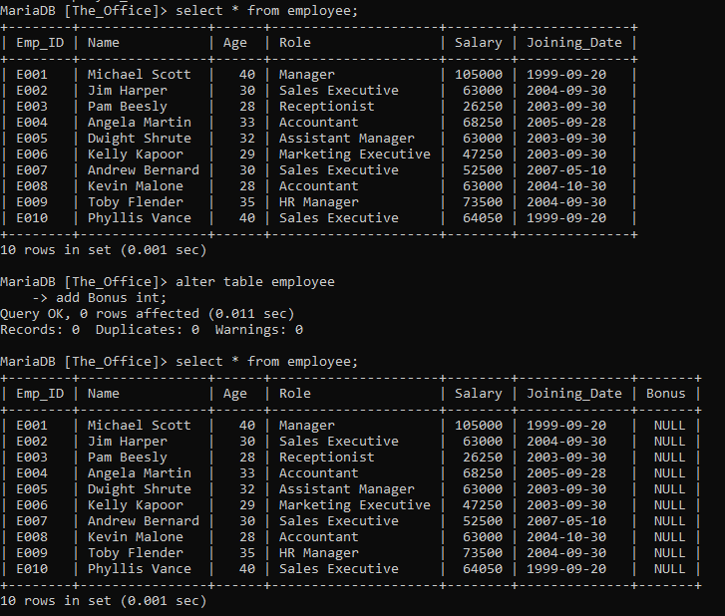

M:

alter table employee

-> drop column bonus;

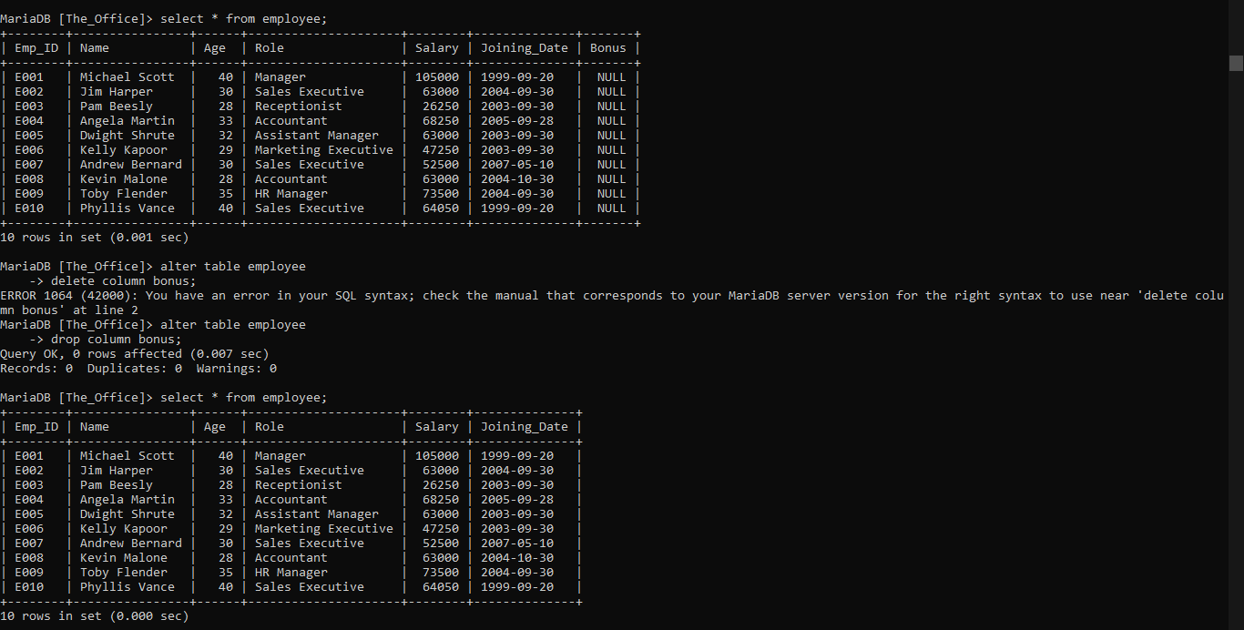

N:

select distinct Role from employee;

